 FOXICON
KyOCeRa CA RANGE INSERT SPECIAL
(WHILE STOCK LAST)
All the prices are including VAT.

List Price Special
WNMG 0804** CA  R80.00 R41.90
CNMG 1204** CA  R80.00 R41.90
TNMG 1604** CA 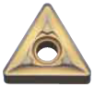 R70.00 R36.90
TNMG 2204** CA 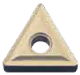 R100.00 R57.90
CCMT 0602** CA  R60.00 R31.90
CCMT 09T3** CA  R80.00 R42.90
DCMT 11T3** CA  R80.00 R43.90
DCMT 0702** CA 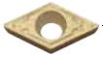 R70.00 R36.90
DNMG 1506** CA 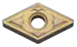 R110.00 R61.90
DNMG 1504** CA 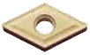 R80.00 R44.90
VNMG 1604** CA  R100.00 R51.90
TPMR 1603** CA  R70.00 R37.90

Please note that all prices are subject to change without prior notice and the orders carry an additional R35 delivery fee (this applies only to the CA range specials)!

